Open your dataset.

Data > save data.

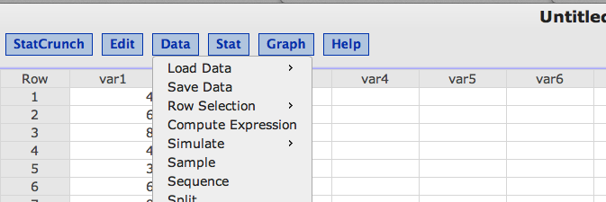

Name your dataset.

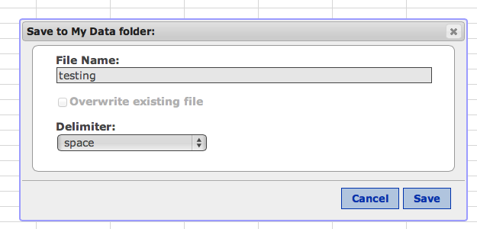

Hit save.

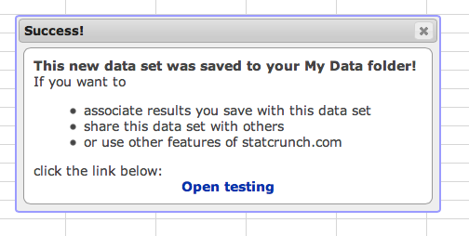

Click “open xxx” (it will say what you called your dataset).

At the very bottom of the screen, I now see this bar:



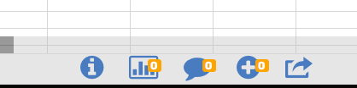

Click on the i circle icon.

You’ll get this window:

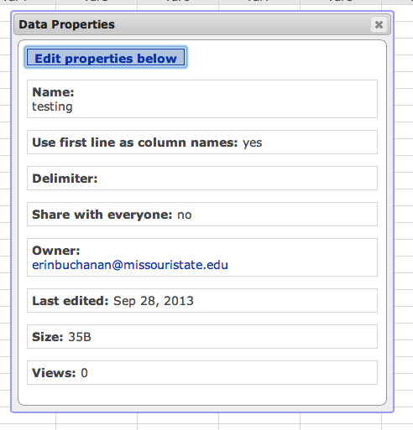

Click edit properties below.

Check your group!

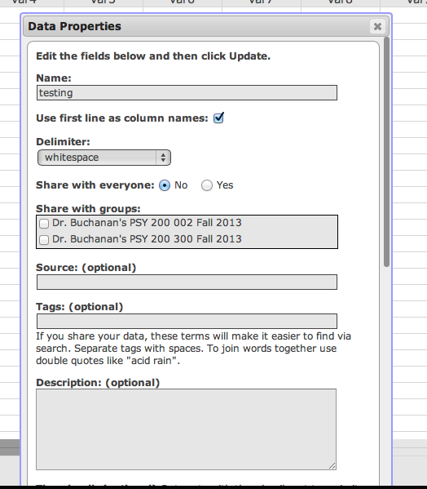

Share with everyone is the link that all stat crunch users can see your data. Clicking on the check box for your group will share it.